**DAILY ONLINE ACTIVITIES SUMMARY**

|  |  |  |  |  |  |  |  |  |
| --- | --- | --- | --- | --- | --- | --- | --- | --- |
| **Date:** | **10-06-2020** | | | | | **Name:** | **Deril Quadras** | |
| **Sem & Sec** | **8 A** | | | | | **USN:** | **4AL16CS031** | |
| **Online Test Summary** | | | | | | | | |
| **Subject** | | **-** | | | | | | |
| **Max. Marks** | | **-** | | **Score** | | | **-** | |
| **Certification Course Summary** | | | | | | | | |
| **Course** | **Introduction to AWS X-ray.** | | | | | | | |
| **Certificate Provider** | | | **AWS** | | **Duration** | | | **10 mins** |
| **Coding Challenges** | | | | | | | | |
| **Problem Statement:**   1. **Write a C Program to print the sum of boundary elements of a matrix.** | | | | | | | | |
| **Status: Solved** | | | | | | | | |
| **Uploaded the report in Github** | | | | | **Yes** | | | |
| **If yes Repository name** | | | | | **Derilquadras/online_c_coding_repository** | | | |
| **Uploaded the report in slack** | | | | | **Yes** | | | |

Online Test Details:

-

Certification Course Details:

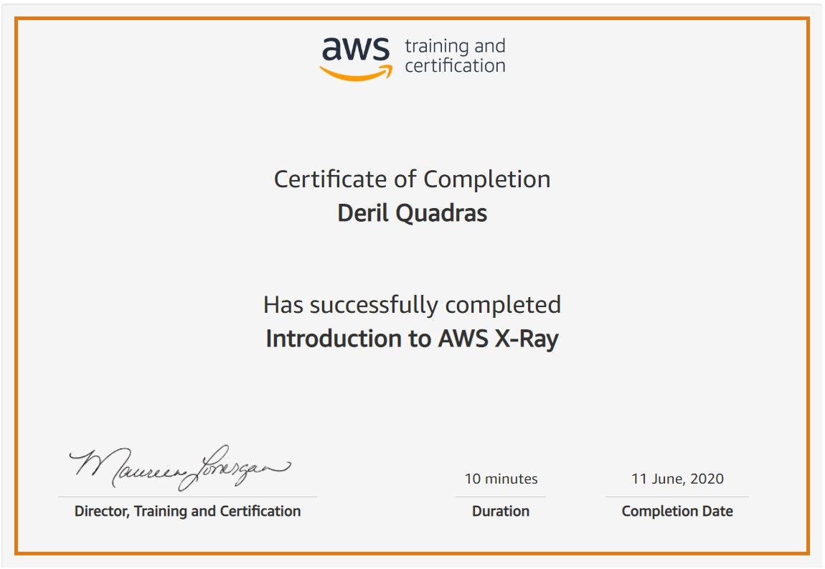

Coding Challenges Details:

**PROGRAM 1 .**

**//Write a C Program to print the sum of boundary elements of a matrix**

**#include <stdio.h>**

**#define MAX 100**

**void printBoundary(int a[][MAX], int m, int n)**

**{**

**for (int i = 0; i < m; i++) {**

**for (int j = 0; j < n; j++) {**

**if (i == 0 || j == 0 || i == n - 1 || j == n - 1)**

**printf("%d",a[i][j]);**

**else**

**printf(" ");**

**printf(" ");**

**}**

**printf("\n");**

**}**

**}**

**int main()**

**{**

**int a[4][MAX] = { { 1, 2, 3, 4 }, { 5, 6, 7, 8 }, { 1, 2, 3, 4 }, { 5, 6, 7, 8 } };**

**printBoundary(a, 4, 4);**

**return 0;**

**}**